**A One Step Solution for Focusing on Tourism**

# Kuntala Govardhan1, Yerragorla Rajesh2, Gandlapenta Siva Ganesh3, Ayush Nandy4

**Abstract**— This project aims to develop a unified booking management system that integrates cab booking, event ticketing, and hotel reservations into a single platform. Built using Django, this web application offers a seamless user experience for individuals and businesses, allowing them to manage various bookings with ease. By leveraging Django’s robust framework, the system provides real-time fare and cost estimations, secure user authentication, and a responsive design. This multi-service booking platform addresses the need for a comprehensive solution, combining multiple booking services that are typically handled independently. The project’s modular structure ensures scalability, enabling future expansion into additional service categories. Through this platform, users benefit from streamlined processes, accurate pricing information, and a centralized booking management system.

**Keywords** - Booking Management System, Django Application, Cab Booking, Event Reservation, Hotel Booking, Real-Time Fare Estimation, User Authentication, Multi-Service Platform, Web Application, Modular Design.

# INTRODUCTION

The rise of online booking platforms has revolutionized the way people make travel, event, and transportation arrangements. However, many existing booking systems are limited in scope, often focusing on only one category, such as transportation or accommodation. This fragmented approach can be inconvenient for users who require multiple types of bookings, especially in scenarios where coordinated planning is essential. The objective of this project is to build a comprehensive booking management system that integrates cab booking, event reservations, and hotel booking capabilities within a single, user-friendly application.

This project uses the Django framework to develop a modular, scalable web application that supports these three distinct booking types. The system allows users to view available cabs, events, and hotels, estimate costs based on specific criteria, and make secure bookings. The application also features user authentication, ensuring that bookings are linked to individual accounts for personalized management. With a responsive design and dynamic pricing calculations, the platform is tailored to meet the diverse needs of modern users, from individual travelers to corporate planners. By consolidating these services into one platform, this project seeks to enhance convenience, reduce booking time, and streamline the process of managing multiple reservations.

**A NEW PARADIGM IN A ONE STEP SOLUTION FOR FOCUSING FOR TOURISM**

**Future Paradigm for Integrated Booking Systems**

As digital tourism and on-demand booking platforms continue to evolve, the future paradigm for integrated booking systems will prioritize seamless, multi-service solutions that adapt to the diverse and changing needs of travelers. The codebase for this Django-based booking application lays a foundation for such a future, where scalability, personalization, and automation play central roles. Here are some potential advancements and directions this project could take in the future:

### 1. **AI-Powered Personalization and Recommendations**

Future iterations could incorporate artificial intelligence to analyze user preferences, past bookings, and current trends to provide personalized recommendations for transportation, events, and accommodations. Machine learning models could predict user preferences, offering tailored suggestions to enhance user satisfaction and increase engagement.

### 2. **Cross-Service Bundling and Dynamic Pricing**

An integrated system could enable cross-service bundling, allowing users to book combined services (e.g., cab to hotel, hotel and event tickets) at discounted rates. Dynamic pricing algorithms could adjust costs in real time based on demand, location, and seasonality, providing users with competitive prices and incentivizing them to book multiple services at once.

### **3. Real-Time Data Integration with External APIs**

The system could integrate with third-party APIs to provide real-time data for flights, public transportation, local events, and weather forecasts, enriching the user experience. By allowing users to make informed decisions with up-to-date information, the platform would enhance planning accuracy and convenience.

### **4. Predictive Maintenance and Service Quality Management**

For cab and hotel booking components, predictive maintenance can be integrated to ensure optimal service quality. For example, predictive algorithms could alert cab operators of maintenance needs before breakdowns occur, ensuring higher reliability. Similarly, hotel management systems could be integrated to monitor room conditions and automate maintenance requests.

### 5. **Blockchain for Secure and Transparent Transactions**

Implementing blockchain technology could enhance transaction transparency and security. Using smart contracts, users could have more secure and tamper-proof booking confirmations, while the decentralized ledger could provide verified records of all transactions, enhancing trust and accountability.

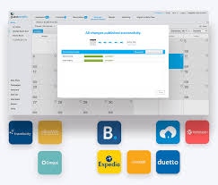

Fig 1

### **6. Multi-Language and Multi-Currency Support for Global Accessibility**

Future versions could incorporate multi-language and multi-currency options, making the platform accessible to an international audience. By dynamically adjusting currency exchange rates and providing localized content, the platform could expand its reach, catering to users from diverse geographical regions.

### 7. **AR/VR for Virtual Tours and Previews**

Integrating augmented reality (AR) or virtual reality (VR) could enable users to take virtual tours of hotels, event venues, or even travel routes. This immersive feature would give users a realistic preview of their experience, helping them make more informed decisions and enhancing the overall booking experience.

### **8. Voice-Activated and Chatbot Booking Assistance**

With advancements in conversational AI, future iterations could include voice-activated booking or AI-powered chatbots to assist users in the booking process. A virtual assistant could handle common queries, suggest services, and even guide users through the booking process, providing a hands-free, efficient experience.

### **9. Eco-Friendly Travel Options and Carbon Footprint Tracking**

As eco-conscious travel becomes more prevalent, the platform could include options for users to select sustainable travel and accommodation options. It could also track the carbon footprint associated with each booking, allowing users to make environmentally responsible choices.

### **10. Data Analytics for Enhanced Business Intelligence**

Advanced data analytics could provide tourism agencies, hotels, and event organizers with insights into user preferences, booking patterns, and market trends. These insights would allow providers to optimize pricing, manage demand, and improve service quality, aligning with future data-driven paradigms in tourism management.

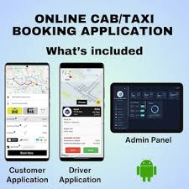

Fig 2

# BENEFITS

Here are the key **benefits** of developing and implementing an integrated booking system like the one described in the code:

### **1. Enhanced User Convenience**

* By consolidating cab, hotel, and event booking into one platform, users can plan and manage multiple aspects of their journey in a single place, eliminating the need to switch between different apps or websites.
* Real-time fare estimation and cost calculation make it easier for users to budget their trips, enhancing overall planning efficiency.

### **2. Improved Personalization**

* With a user account system, bookings and preferences are personalized, allowing the platform to offer recommendations and customizations based on past behaviors and interests.
* This personalized experience can increase user satisfaction, as the platform remembers preferences, suggests relevant services, and makes each visit more tailored to individual needs.

### **3. Streamlined Booking Process**

* By providing a unified platform, this solution simplifies the booking process, reducing the time and effort required for users to complete multiple bookings.
* A cohesive booking experience can reduce abandonment rates, as users are less likely to be frustrated or overwhelmed with a multi-step, disconnected process.

### **4. Scalability for Service Expansion**

* The modular design allows for easy expansion into additional service areas (e.g., flight bookings, car rentals, or dining reservations) without needing to overhaul the entire system.
* This scalability makes it ideal for tourism platforms aiming to grow and diversify their offerings over time, creating a flexible foundation that can adapt to future needs.

### **5. Increased Business Insights**

* Data collected on user preferences, booking patterns, and service demand provides valuable insights for tourism agencies, transportation providers, and event organizers.
* Analytics from this data enable businesses to optimize pricing, improve service quality, adjust to demand trends, and offer targeted promotions, ultimately enhancing profitability and competitiveness.

### **6. Cost and Time Savings for Users**

* The platform’s dynamic cost estimation and potential bundling options (e.g., booking cabs, hotels, and events together) offer users better pricing and more budget-friendly options.
* Users save time by planning, booking, and managing all services from a single platform, allowing them to focus more on their travel experience rather than logistics.

### **7. Secure and Reliable Transactions**

* With a secure login and user authentication, each booking is tied to a specific user account, reducing the risk of fraud and unauthorized bookings.
* Users gain confidence in the platform’s reliability, as they can securely manage and view their bookings, payment histories, and other personal information.

### **8. Enhanced User Retention and Loyalty**

* Offering multiple services in one place encourages users to return to the platform for various booking needs, fostering loyalty and engagement.
* A streamlined, positive booking experience can lead to repeat bookings and increased word-of-mouth recommendations.

# PRACTICAL EXAMPLE

# cab_booking/models.py

from django.db import models

from django.contrib.auth.models import User

class Cab(models.Model):

cab_type = models.CharField(max_length=50)

base_fare = models.DecimalField(max_digits=5, decimal_places=2)

per_km_rate = models.DecimalField(max_digits=5, decimal_places=2)

class CabBooking(models.Model):

cab = models.ForeignKey(Cab, on_delete=models.CASCADE)

user = models.ForeignKey(User, on_delete=models.CASCADE)

pickup_location = models.CharField(max_length=100)

drop_location = models.CharField(max_length=100)

pickup_time = models.DateTimeField()

distance = models.DecimalField(max_digits=6, decimal_places=2, default=0)

estimated_fare = models.DecimalField(max_digits=8, decimal_places=2)

cab_booking/views.py

from django.shortcuts import render, get_object_or_404, redirect

from .models import Cab, CabBooking

from django.contrib.auth.decorators import login_required

from datetime import datetime

from decimal import Decimal # Import Decimal to handle conversions

# List of available cabs

def cab_list(request):

cabs = Cab.objects.all()

return render(request, 'cab_booking/cab_list.html', {'cabs': cabs})

def estimate_fare(request, cab_id):

cab = get_object_or_404(Cab, id=cab_id)

estimated_fare = None

distance = pickup_location = drop_location = pickup_time = None

if request.method == 'POST':

# Use get() to handle missing fields gracefully

distance = request.POST.get('distance')

pickup_location = request.POST.get('pickup_location')

drop_location = request.POST.get('drop_location')

pickup_time = request.POST.get('pickup_time')

# Ensure all required fields are present

if distance:

distance = Decimal(distance)

estimated_fare = cab.base_fare + (distance * cab.per_km_rate)

return render(request, 'cab_booking/fare_estimation.html', {

'cab': cab,

'estimated_fare': estimated_fare,

'distance': distance,

'pickup_location': pickup_location,

'drop_location': drop_location,

'pickup_time': pickup_time,

})

def booking_confirmation(request, booking_id):

booking = get_object_or_404(CabBooking, id=booking_id)

return render(request, 'cab_booking/booking_confirmation.html', {'booking': booking})

@login_required

def book_cab(request, cab_id):

cab = get_object_or_404(Cab, id=cab_id)

if request.method == 'POST':

pickup_location = request.POST['pickup_location']

drop_location = request.POST['drop_location']

pickup_time = request.POST['pickup_time'] # Already in the correct format from the form

distance = Decimal(request.POST['distance'])

estimated_fare = cab.base_fare + (distance * cab.per_km_rate)

# Create the CabBooking record

booking = CabBooking.objects.create(

cab=cab,

user=request.user,

pickup_location=pickup_location,

drop_location=drop_location,

pickup_time=pickup_time,

distance=distance,

estimated_fare=estimated_fare

)

return redirect('cab_booking:booking_confirmation', booking_id=booking.id)

return render(request, 'cab_booking/book_cab.html', {'cab': cab})

# event_booking/models.py

from django.db import models

from django.contrib.auth.models import User

class Event(models.Model):

name = models.CharField(max_length=100)

venue = models.CharField(max_length=200)

event_date = models.DateField()

ticket_price = models.DecimalField(max_digits=6, decimal_places=2)

total_tickets = models.IntegerField(default=100) # Add a default value for total tickets

tickets_sold = models.IntegerField(default=0)

class EventBooking(models.Model):

event = models.ForeignKey(Event, on_delete=models.CASCADE)

user = models.ForeignKey(User, on_delete=models.CASCADE)

number_of_tickets = models.IntegerField()

total_price = models.DecimalField(max_digits=8, decimal_places=2, default=0)

event_booking/views.py

from django.shortcuts import render, get_object_or_404, redirect

from .models import Event, EventBooking

from django.contrib.auth.decorators import login_required

# List of available events

def event_list(request):

events = Event.objects.all()

return render(request, 'event_booking/event_list.html', {'events': events})

# Event details view

def event_detail(request, event_id):

event = get_object_or_404(Event, id=event_id)

return render(request, 'event_booking/event_detail.html', {'event': event})

def booking_confirmation(request, booking_id):

booking = get_object_or_404(EventBooking, id=booking_id)

return render(request, 'event_booking/booking_confirmation.html', {'booking': booking})

@login_required

def book_event(request, event_id):

event = get_object_or_404(Event, id=event_id)

if request.method == 'POST':

number_of_tickets = int(request.POST['number_of_tickets'])

total_price = event.ticket_price * number_of_tickets

# Check if there are enough tickets available

if event.tickets_sold + number_of_tickets <= event.total_tickets:

# Create the EventBooking record

booking = EventBooking.objects.create(

event=event,

user=request.user,

number_of_tickets=number_of_tickets,

total_price=total_price

)

# Update the tickets_sold count

event.tickets_sold += number_of_tickets

event.save()

return redirect('event_booking:booking_confirmation', booking_id=booking.id)

else:

# If not enough tickets are available, render an error page or message

return render(request, 'event_booking/event_unavailable.html', {'event': event})

return render(request, 'event_booking/book_event.html', {'event': event})

# hotel_booking/models.py

from django.db import models

from django.contrib.auth.models import User

class Hotel(models.Model):

name = models.CharField(max_length=100)

location = models.CharField(max_length=100)

description = models.TextField()

price_per_night = models.DecimalField(max_digits=6, decimal_places=2)

class Booking(models.Model):

hotel = models.ForeignKey(Hotel, on_delete=models.CASCADE)

user = models.ForeignKey(User, on_delete=models.CASCADE)

check_in_date = models.DateField()

check_out_date = models.DateField()

guests = models.IntegerField()

total_price = models.DecimalField(max_digits=8, decimal_places=2, default=0) # Add this line if it�s missing

hotel_booking/views.py

from django.shortcuts import render, get_object_or_404, redirect

from .models import Hotel, Booking

from django.contrib.auth.decorators import login_required

from datetime import datetime

# List of hotels

def hotel_list(request):

hotels = Hotel.objects.all()

return render(request, 'hotel_booking/hotel_list.html', {'hotels': hotels})

# Hotel details view

def hotel_detail(request, hotel_id):

hotel = get_object_or_404(Hotel, id=hotel_id)

return render(request, 'hotel_booking/hotel_detail.html', {'hotel': hotel})

def booking_confirmation(request, booking_id):

# Retrieve the booking by ID or return 404 if not found

booking = get_object_or_404(Booking, id=booking_id)

# Render the confirmation template and pass booking details

return render(request, 'hotel_booking/booking_confirmation.html', {'booking': booking})

@login_required

def book_hotel(request, hotel_id):

hotel = get_object_or_404(Hotel, id=hotel_id)

if request.method == 'POST':

check_in_date = datetime.strptime(request.POST['check_in_date'], "%Y-%m-%d")

check_out_date = datetime.strptime(request.POST['check_out_date'], "%Y-%m-%d")

guests = int(request.POST['guests'])

total_days = (check_out_date - check_in_date).days

total_price = hotel.price_per_night * total_days * guests

# Ensure 'total_price' is included if it exists in the model

booking = Booking.objects.create(

hotel=hotel,

user=request.user,

check_in_date=check_in_date,

check_out_date=check_out_date,

guests=guests,

total_price=total_price

)

return redirect('hotel_booking:booking_confirmation', booking_id=booking.id)

return render(request, 'hotel_booking/book_hotel.html', {'hotel': hotel})

**OUTPUT**

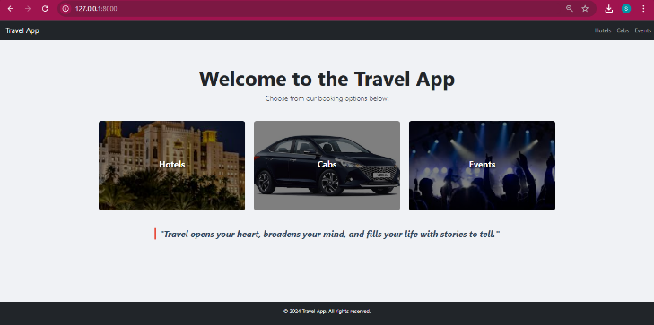

Fig 3

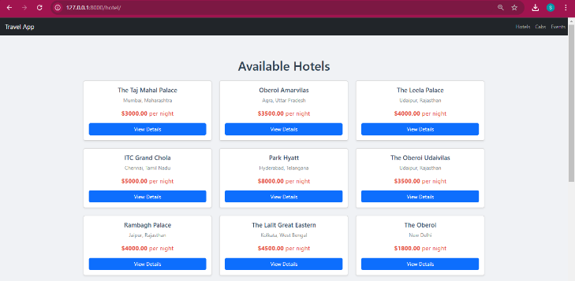

Fig 4

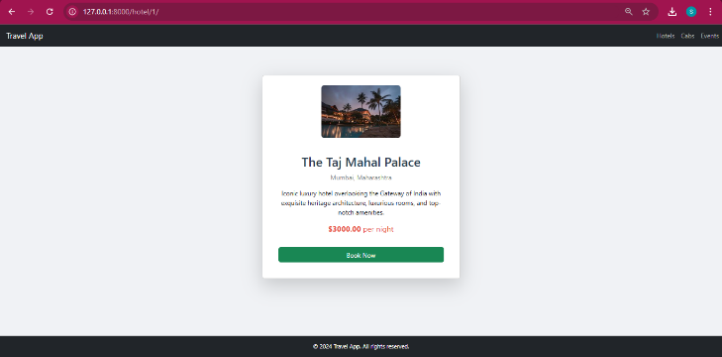

Fig 5

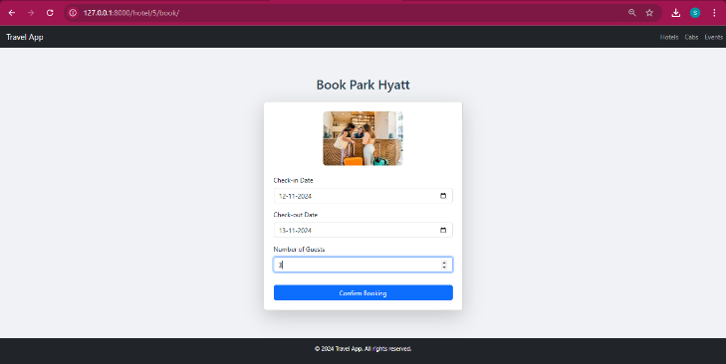

Fig 6

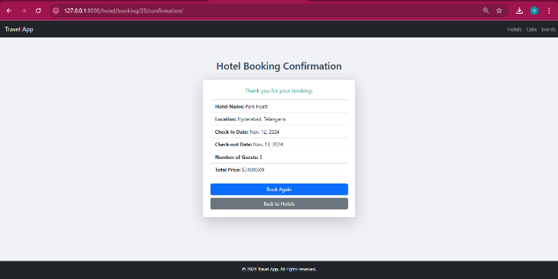

Fig 7

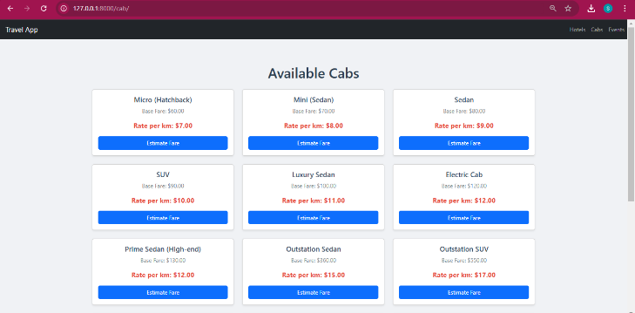

Fig 8

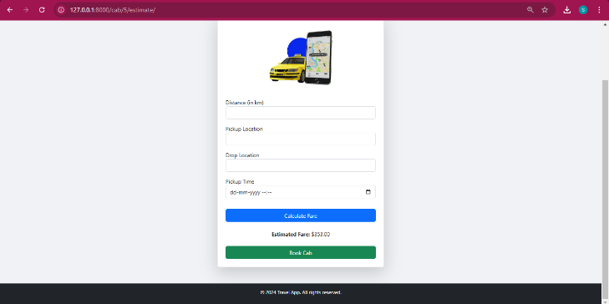

Fig 9

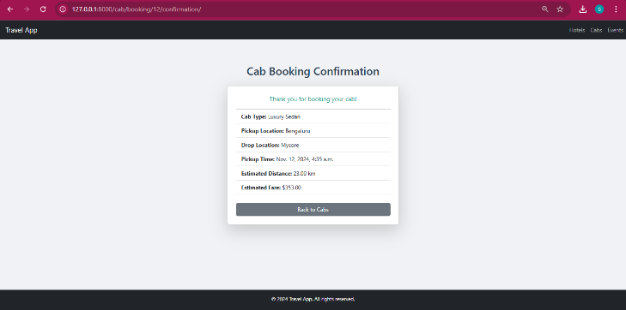

Fig 10

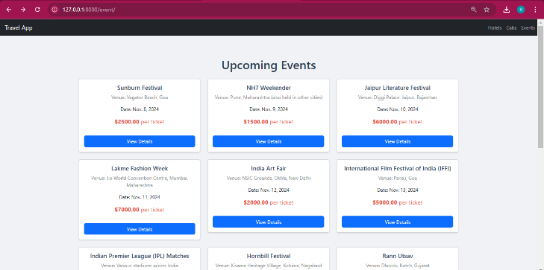

Fig 11

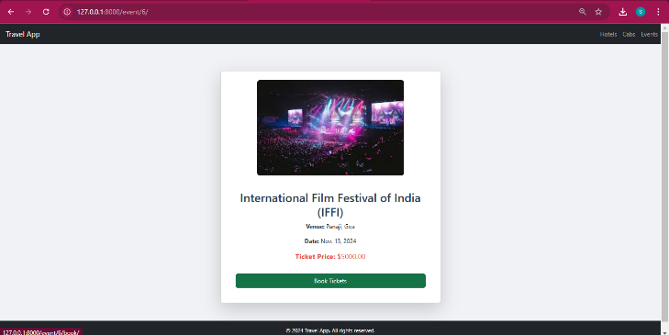

Fig 12

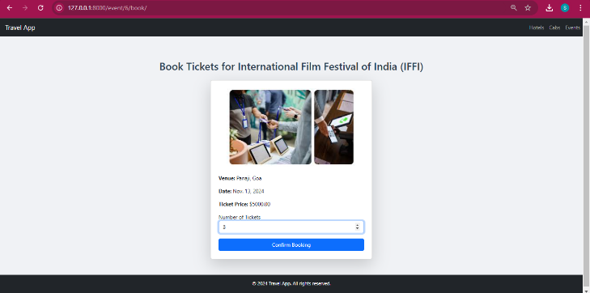

Fig 13

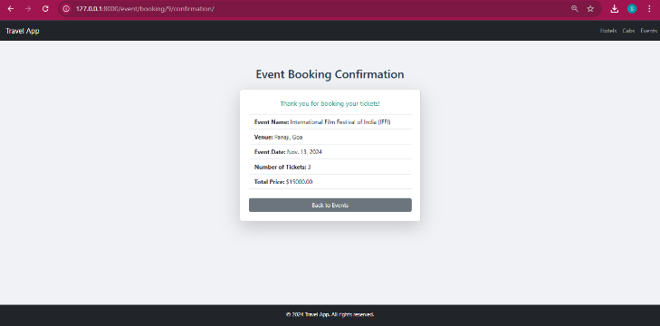

Fig 14

# CHALLENGES

**Data Integration and Accuracy**

* Integrating real-time data from multiple sources (e.g., cab services, hotel availability, event schedules) can be complex. Ensuring that this data is accurate, consistent, and updated promptly is critical to maintaining user trust.
* Discrepancies in availability or pricing information from external APIs can lead to user frustration and abandoned bookings.

**Scalability and Performance**

* As user demand grows, the platform needs to handle large volumes of traffic and transactions. Ensuring that the platform scales without compromising performance is essential, especially during peak travel seasons.
* Optimizing database queries, caching frequently accessed data, and load balancing are important to avoid slowdowns and crashes.

**Security and Privacy**

* Handling sensitive user data, including personal details and payment information, requires stringent security measures. The platform must comply with data protection regulations (such as GDPR) to protect user privacy.
* Preventing unauthorized access, fraud, and cyberattacks is crucial, especially in a platform that involves transactions and user accounts.

**User Experience Consistency**

* Providing a seamless user experience across multiple booking services can be challenging, as each service may have unique workflows and requirements.
* Ensuring a consistent design, intuitive navigation, and clear booking processes across cab, event, and hotel bookings is key to retaining users.

**Complexity in Payment and Refund Handling**

* Managing payments and refunds across different services (cabs, events, hotels) requires careful planning. Different service providers may have unique payment and cancellation policies, which need to be accounted for in the system.
* Processing refunds promptly and transparently is essential to maintain customer satisfaction.

**Maintaining Partnerships with Service Providers**

* For an integrated booking platform to succeed, reliable partnerships with cab companies, hotels, and event organizers are essential. Building and maintaining these partnerships require ongoing communication, negotiation, and alignment on service standards.
* Changes in partnerships or service provider policies can disrupt the platform, requiring adjustments and adaptations.

**Handling Real-Time Availability and Cancellations**

* Keeping availability updated in real-time for various bookings is a technical challenge. For instance, cab availability and hotel room occupancy can change quickly.
* Managing cancellations, overbooking, and last-minute availability changes without impacting the user experience is crucial.

**ADDITIONAL CONSIDERATIONS**

• **Localization and Multi-Currency Support**

* To expand globally, the platform should support multiple languages and currencies, making it accessible to a wider audience. This includes dynamically updating currency conversion rates and providing localized content for different regions.

• **Eco-Friendly Options and Sustainability Initiatives**

* With a growing demand for sustainable travel options, the platform could include filters for eco-friendly services, such as green-certified hotels and fuel-efficient cabs. Tracking the carbon footprint of each booking could be an added feature to appeal to eco-conscious users.

• **Loyalty and Reward Programs**

* Offering loyalty points or rewards for frequent users can help increase user retention. Implementing a system that allows users to accumulate points with each booking and redeem them for discounts or special offers can add value to the user experience.

• **AI-Driven Insights for Business Partners**

* Using AI and data analytics, the platform can offer insights to business partners, such as cab companies, hotels, and event organizers, on customer preferences, peak booking times, and service demand trends. This helps partners optimize their services and make data-driven decisions.

• **Responsive Design for Multiple Devices**

* Ensuring the platform is mobile-friendly and performs well on various devices is essential, as users may book services on the go. A responsive design that adapts to different screen sizes enhances accessibility and user satisfaction.

# CONCLUSION

This integrated booking platform represents a new paradigm in tourism and travel services, combining multiple booking functions into a unified, user-centric solution. By offering cab, event, and hotel booking in a single platform, the system enhances convenience, streamlines the booking process, and provides users with a seamless experience from start to finish.

Despite the challenges of data integration, scalability, security, and real-time availability, this platform offers a strong foundation for addressing the diverse needs of modern travelers. Its modular architecture allows for future expansion and adaptation, positioning it as a versatile tool in the evolving landscape of digital tourism.

# REFERENCES

# Kernel, P. Creating and implementing a model for sustainable development in tourism enterprises.

# Anita Zehrer, Ph.D. (2013). Journal of Tourism.

# Khodair, A. M. Tourism Systems Thinking: Towards an Integrated Framework to Guide the Study of the Tourism Phenomenon.

# Khodair, A. M. System Thinking Versus Conventional Thinking in Tourism Research

# Arbuckle, J. J. and Wothke, W. (1999), AMOS 4.0 users' guide. Chicago, IL: Smallwaters Corporation.

# Barney, J. (1991), “Firm Resources and sustained Competitive Advantage”, Journal of Management, Vol. 17, No. 1, pp. 99-120. Bransch, N. (2005), Service Engineering, Berlin, VDM.

# Chan, A., Go, F. and Pine, R. (1998), “Service Innovation in Hong Kong: Attitudes and Practice”, The Service Industries Journal, Vol. 18, No. 2, pp. 112-124.

# Coombs, R., and Miles, I. (2000),” Innovation, Measurement and Services: The new Problematique”, in Metcalfe, J. S., and Miles, I. (Eds.), Innovation Systems in the Service Economy, Kluwer Academic Publ, Boston, Massachusetts, pp. 85- 103.

# Coombs, R., and Miles, I. (2000),” Innovation, Measurement and Services: The new Problematique”, in Metcalfe, J. S., and Miles, I. (Eds.), Innovation Systems in the Service Economy, Kluwer Academic Publ, Boston, Massachusetts, pp. 85- 103.

# Danneels, E. (2007), “The process of technological competence leveraging”, Strategic Management Journal, Vol. 28, No. 5, pp. 511-533.

# DeFrank, R.S., Konopaske, R. and Ivancevich, J.M. (2000), “Executive Travel Stress: Perils of the Road Warrior”, Academy of Management, Vol. 14, pp. 58- 71.

# Dosi, G. (1988), “The nature of the innovation process”, in Dosi, G., Freeman, C., Nelson, R., Silverberg, G. and Soete, L. (Eds.), Technical change and economic theory, Pinter, London, pp. 221-238.

# Drejer, I. (2004), “Identifying innovation in surveys of services: a Schumpetrian perspective”, Research Policy, Vol. 33, No. 3, pp. 551-562.

# European Commission (2004), Innovation in Europe, retrieved [http://epp.eurostat.ec.europa.eu/cache/ITY_OFFPUB/KS-59-04- 257/EN/KS-59-04-257-EN.PDF](http://epp.eurostat.ec.europa.eu/cache/ITY_OFFPUB/KS-59-04-%20257/EN/KS-59-04-257-EN.PDF).

# Flagestad, A, and Hope, C.A. (2001), “Strategic Success in Winter Sports Destinations”, Tourism Management, Vol. 22, No. 5, pp. 445-461.

# Flagestad, A., Hope, C. A., Svensson, B. and Nordin, S. (2005), “The tourist destination: a local innovation system? The creation of a model”, in Keller, P. and Bieger, T. (Eds.), Innovation in tourism - creating customer value, AIEST, St. Gallen, pp. 245-259.